

Faculty of Engineering and Applied Science

ENGR 4940U Capstone Systems Design for ECSE I

**Design and Development of Reminiscence Media for Dementia Patients**

R2: Concept Generation, Conceptual Design and Prototype

**Team Members**

Nafis Mobassher 100587562

Muhtasim Chowdhury 100584755

Sakib Shahriyar 100587434

**Faculty Advisor**: Dr. Ramiro Liscano

**Capstone Coordinator (Fall 2019)**: Dr. Q. Mahmoud

**Table of Contents**

Concept Generation Analysis……………………………………………………………….3

Conceptual System Design………………………………………………………………….3

Definition of Integration Tests………………………………………………………………7

Estimated Costs……………………………………………………………………………...8

Updated Project Plan………………………………………………………………………...9

Contribution Matrix…………………………………………………………………………10

References…………………………………………………………………………………...11

**List of Tables**

* 1. Use Case Table…………………………………………………………………………..5

1.2 Quality Attributes Table………………………………………………………………6

1.3 Constraints table………………………………………………………………………….6

5.1: Updated Project Plan………………………………………………………………….13

6.1 Contribution Matrix……………………………………………………………………14

**List of Figures**

2.1: Architectural Model……………………………………………………………………….4

2.2: Deployment Diagram………………………..…………………………………………….5

2.3: Sequence Diagram………………………..……………………………………………….6

2.4: Initial Database Diagram………………………………………………………………….7

**1.** **Concept Generation and Analysis:**

In this project we have two concepts that we have to generalize and analyze. First concept is our security process in this project. Users will want to have a secure environment where they can upload any sensitive media files onto the cloud without worrying about the security of it. We conducted some research on how we can make the environment more secure and we have decided to have a user authentication system. This system authorizes human to machine interactions in networks and interconnected systems. Many websites use user authentication to validate which users have logged into the system. Authentication is necessary because it will enable Ontario Shores to keep their networks secure by only allowing authenticated users access to protected resources, which includes sensitive media files. During authentication, passwords provided by the users are compared to those on a file in a database of authorized user information. If the credentials are matched then the process is complete and the user is granted access to the media files. With the increasing number of internet enabled devices, reliable system authentication is crucial to enable secure communication for users. There are many methods for implementing user authentication, we decided to keep it simple and thus making sure it is as reliable as possible. Essentially, users with permission will have their information stored on a cloud database, and when they attempt to log in, the web application will retrieve the database information and check to see if it matches with the user inputted data. If the match is successful, the login will be successful, else, there will be a prompt to notify the client of the failure to login.

The second major concept is the cloud system that we will be using. We are required to use a Canadian cloud system and through our research we have decided to go with TeraGo Networks. TeraGo is partnered with AWS and it provides us with a fast and secure database. TeraGo specializes in big databases and uses AWS tools to make sure that users have better security posture. With TeraGo, the systems and database will be safe and secure, and we can work in confidence and prevent damage.

An alternate to using cloud storage would have been to opt towards using local storage. The main reason we chose to go the route of cloud storage because it ends up becoming cheaper to store large amounts of data on the cloud rather than having to purchase and manage hardware to store large amounts of data locally. Another advantage would be that there would not be any need for maintenance on the storage system if the cloud approach is taken. This is because cloud storage providers handle any upgrades or issues that may arise. Another huge advantage to cloud storage is that it allows for easy stability. This is because it is an extremely simple process to get more storage, you simply as your provider. Whereas, if local storage was used, you would need to improve the hardware to handle more data. However, there are advantages to local storage, one of the major ones being speed.

USE CASE TABLE 1.1

|  |  |
| --- | --- |
| **ID** | **Description** |
| UC-1 | Care-givers can only view their patients profile |
| . | Staff can view all patient profiles and general profiles |
| UC-3 | Users will be able to log in successfully based on their credentials |
| UC-4 | Users can successfully upload media and answer the questions on patient profile |
| UC-5 | User can successfully modify patient profile |
| UC-6 | User can successfully log out |

Quality Attributes Table 1.2

|  |  |  |  |
| --- | --- | --- | --- |
| **ID** | **Quality Attribute** | **Scenario** | **Priority** |
| QA-1 | Performance | -multiple users need to be able to access the web application without data loss  -application must not slow down when there are many users active | High |
| QA-2 | Modifiability | -staff will be able to modify patient profiles  -code will be properly structured so that it can be improved at any time | High |
| QA-3 | Availability | -application should always be online  -TeraGo cloud services will provide that availability | Medium |
| QA-4 | Usability | -application must be simple to use  -not a steep learning curve | High |
| QA-5 | Security | -user authentication is used for security  -2-factor authentication will be implemented  -media files should only be visible to the correct patients  -passwords will be encrypted | High |

Constraints Table 1.3

|  |  |
| --- | --- |
| **ID** | **Constraints** |
| CON-1 | Can have only one care-giver per patient |
| CON-2 | Must have at least 1TB of storage according to TeraGO policy. |
| CON-3 | File content attacks: The content of the ipload can manipulate the database |
| CON-4 | Only one method of registration |

**2.** **Conceptual System Design**

With the two concepts set in mind, we have to come up with ways that will help users maintain their privacy, as well as have a system that can store information in a safe manner. With the first concept, we will be using user authentication which will help keep data separate for each user in the system. Depending on the final requirements, we may need to create profiles for each patient for our website. But, if we can use the same credentials that are already present for each patient in Ontario Shores from their database, that would be beneficial. In order to make the username and passwords secure, we will need to encrypt the data. We will look to implement a hash function which takes the password of a user and makes it unique so no one can identify the password. With just encryption, one would be able to decrypt the information, with the same information being restored, in this case the password. We do not want this, so by using a hash function, we would be able to uniquely identify the password, but not be able to restore the password to its original state. We will also add a “salt” to our hash function. This means that we will add a random piece of text to our function, making it harder for brute forcing to occur. We will also make sure that each password will contain different random pieces of text.

The final main concept of our website is the cloud. The cloud we will use will provide us with more security and less hassle than actually having a physical server. We will have our hashes stored in the cloud, as well as media files of each patient. We will categorize the media files by file type and also contain default media files already in the system.

With the software components verified, we will also need to verify the hardware components of the system which will be completed by another group. We need to make sure that our website will be useful in showing the virtual reality aspect of our media files that are going to be projected. We need to make sure that the hardware is able to clearly show the media files onto the projector and also have our website be able to comply to the hardware requirements. We will also look to make a mobile version of this application as most media nowadays are transferred through mobile rather than using a computer which would contain scanned images.

The process diagram (Figure 2.1) below explains how media is stored into the cloud and how it is retrieved from the user. The user would need to log in. Then, they would make changes to the website such as uploading or deleting files from their profile. This information would be stored onto the cloud. The cloud would save the information and update the website. It will also be able to send the data onto another interface. We will implement a button that will transfer the media files being presented onto a display. The button will redirect the information to another site, which will use the info collected to categorized and show media files using a virtual reality system.

The process diagram below shows a general flow of the system we have so far. Our main focus is for the caregiver or staff to log in to their account and be able to make changes to the web app by uploading or deleting media files for their account.

Figure 2.1 Process Diagram

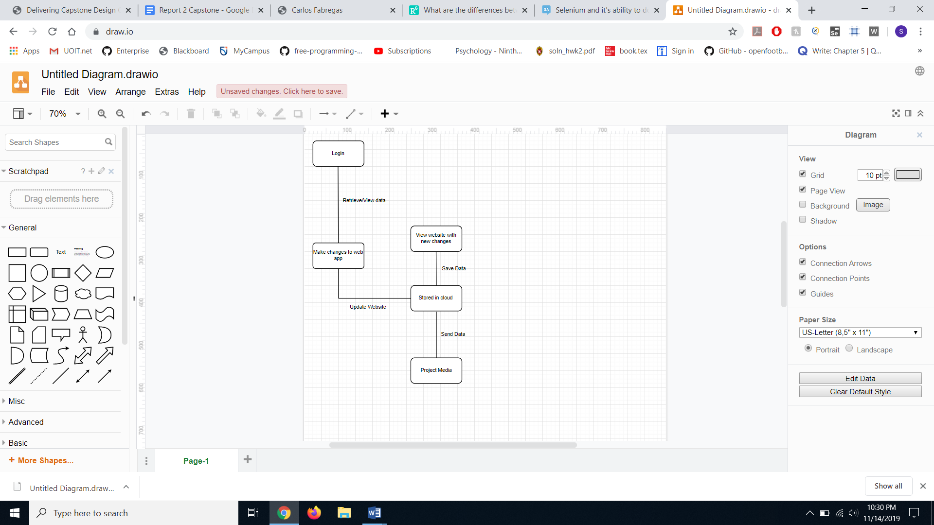

The process diagram (Figure 2.2) below shows the execution path of the system in more detail and how they are connected. Step 1: The login page makes the user choose either care giver or staff login. Login is authenticated and passwords are hashed for privacy. Step 2: If care giver is logged in, they can do a few things to their patient’s profile. They can add or update information as well as media. They can play the media for the patient. If a staff is logged in, they can see all of the patients’ profiles. They can also add or update information for the patient as well as the media. They can also play the media for a specific patient or play generic media for a group of patients. Staff users can also add and delete patient profiles. Both types of users are able to log out.

.

Figure 2.2 Process Diagram 2

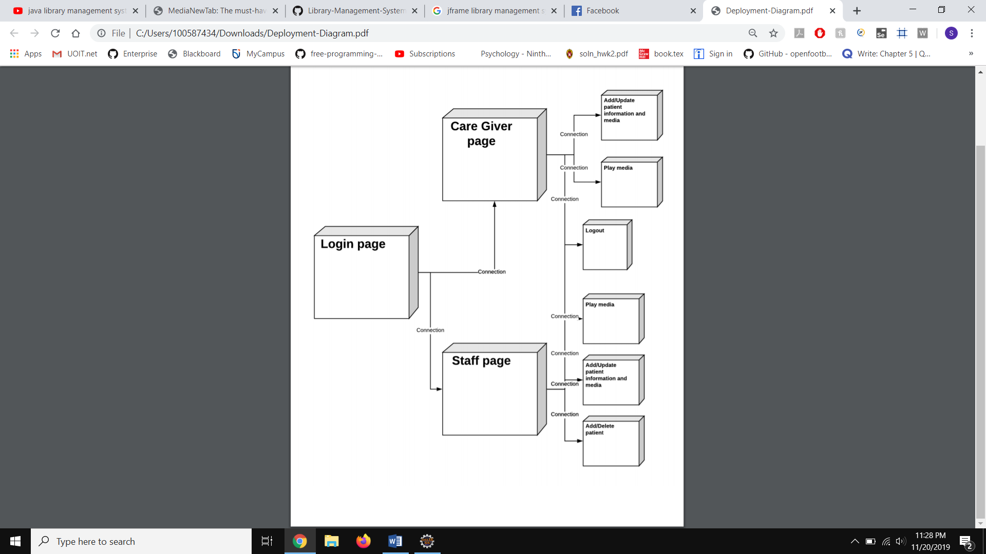

The Architecture Diagram (Figure 2.3) below shows the architecture of our system with the cloud services from TeraGo, which uses Amazon AWS. Amazon AWS has lots of services built-in that we will be using. We will be using Amazon CloudFront which utilizes Amazon Simple Storage (S3). Amazon CloudFront is essentially a global network of edge locations. Amazon Simple Storage is a highly durable storage infrastructure designed primarily for data storage. This storage can be used to supply static content for the website. We will also be using Amazon Cognito User Pools which uses AWS STS to retrieve credentials for user authentications. We will also be using AWS Lambda which provides the backend for the web application. AWS Lambda will remove the need for a server since all of the code can be uploaded to AWS which is make it easier to manage infrastructure. Lastly, Amazon DynamoDB will be used to provide database solutions. Amazon DynamoDB provides fast, consistent performance as the data layer of the web application.

Figure 2.3 Architecture Diagram



The deployment Diagram (Figure 2.4) below shows how the deployment of our application will work. The user will invoke the client side application from their workstation, which will access the application server from the cloud. This application server is also connected to the cloud database which stores all of the user information as well as the media information,

Figure 2.4 Deployment Diagram



The diagram (Figure 2.5) below shows that there are 3 objects in the login authentication process of our website. The actor types in their credentials. In our case the actors would be the patient/staff or caregiver. They would then click the login button from the login page. The user is validated by the id and password that they are given, and if they match in the database. If the id is found and it matches the password, the database would send the info of the specific media content of that patient. The screen would then display various media files that the user can choose from and use for the presentation portion of the website, which will be projected onto another display.

Figure 2.5 Sequence Diagram for authentication

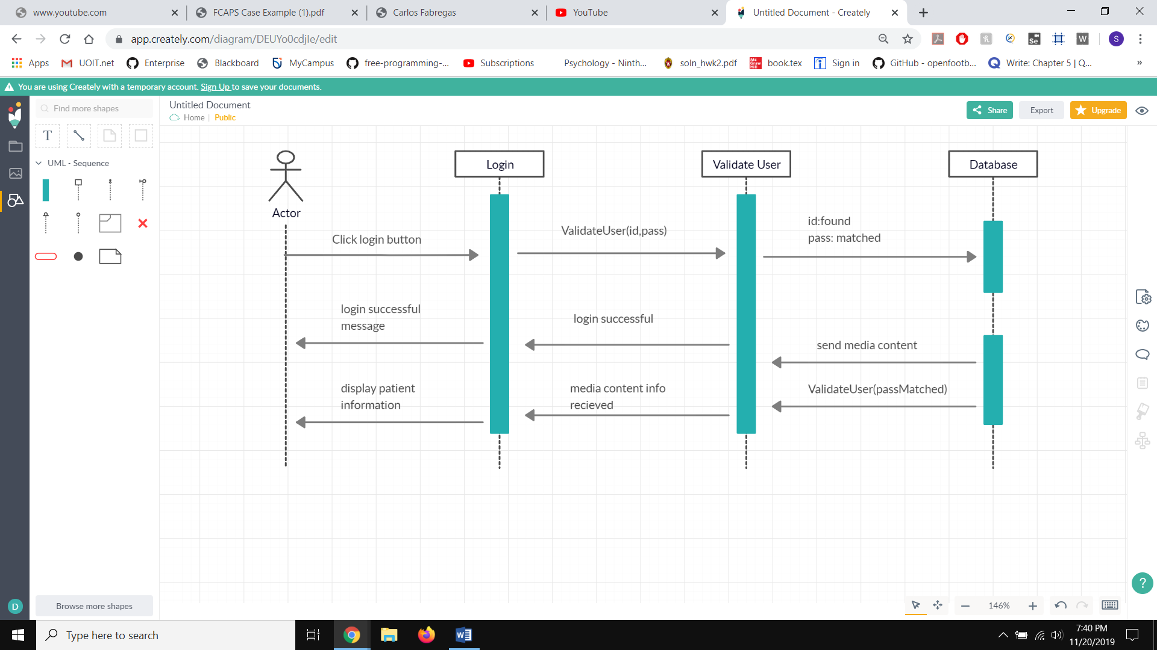

Figure 2.6 Sequence Diagram for media content

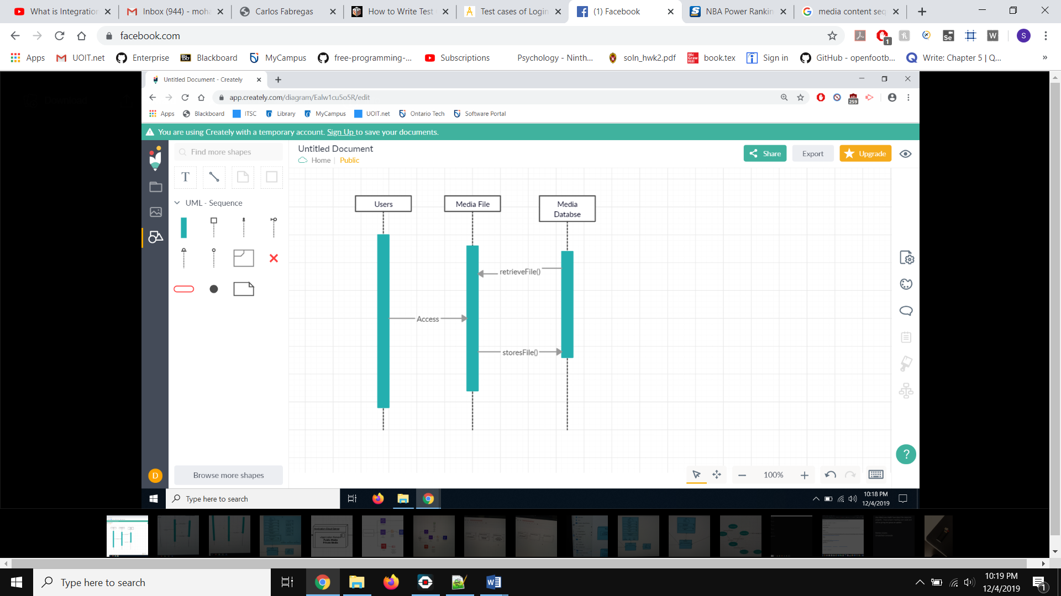

Our cloud database will consist of four main tables. The care giver and staff tables are where the login information is stored. The patients table will have the information about the patient (name, joined) and also security questions. But it will also have the mediaID which will connect them to the media database where the media is stored as well as the URL for streaming the content onto another device.

Figure 2.6 Database Diagram

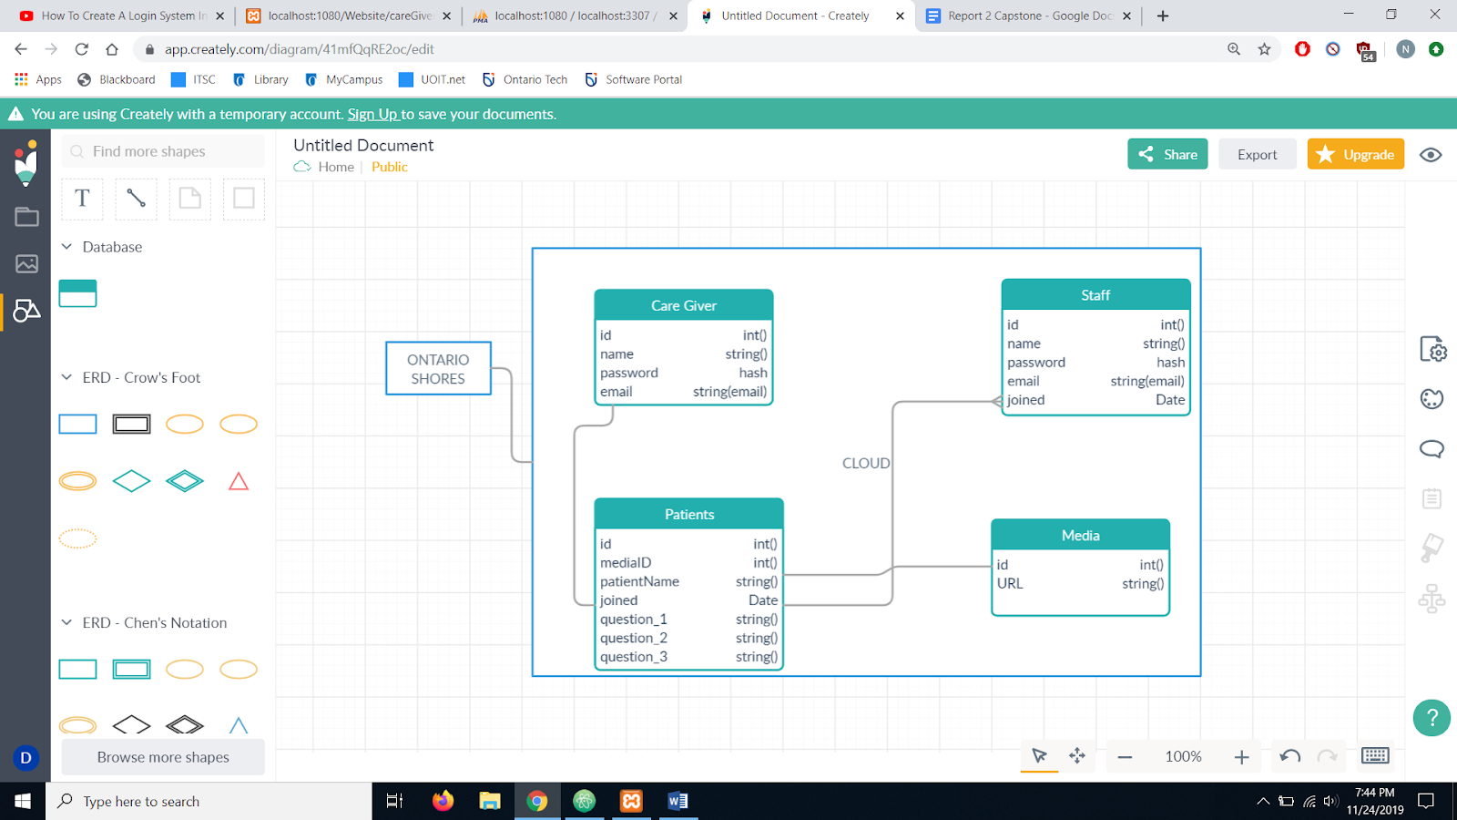

**3.** **Definition of Integration Tests**

In this phase we combine our individual software modules and test them as a group. Each member will be working on different parts of the integration of the project. We will be using the big bang approach where most of the developed modules will be combined and used for integration testing. This method will save us time and it is very effective. Our test cases have been recorded properly and there will not be any complications for our testing. The unity of our modules will be tested as an entity. Bing bang approach tests the whole system as a whole and it will consist of completed modules and it is suitable for our system.

In order to get the definition of integration tests, we first need to look at which components needed to be combined in order to complete the testing in one go. Components would include, user authentication, website results verification and validation, and cloud testing. We will be using automation tools such as Selenium to do the testing. Our main concern is to implement the software portion of our website to the hardware portion, which is the projection of the media to a virtual reality system.

|  |  |
| --- | --- |
| **Test Cases for Login Page** | |
| **Test Case** | **Description** |
| T1 | Verify that user is able to log in with a valid username and password. |
| T2 | Verify that user is not able to log in when username and password is invalid. |
| T3 | Verify message is displayed when text field is left blank and login button is clicked. |
| T4 | Verify that the password is encrypted when it is entered. |
| T5 | Verify the timeout functionality of the login session. |
| T6 | Verify that a message is displayed if user types in wrong username or password. |
| T7 | Verify that the user can press enter to login. |
| T8 | Verify the time taken to get to the login page once user puts in the correct credentials. |

|  |  |
| --- | --- |
| **Test Cases for Media Content** | |
| **Test Case** | **Description** |
| T1 | Verify that user is able to access media files specific to their profile. |
| T2 | Verify that user is not able to access other patient’s media files. |
| T3 | Verify user is able to access default files in database. |
| T4 | Verify that user is able to upload media file. |
| T5 | Verify that user can upload media file up to the maximum size. |
| T6 | Verify that user is able to upload any type of media file (jpg, png, mp4, etc) |
| T7 | Verify that user can add tags to files that they upload. |

|  |  |
| --- | --- |
| **Test Cases for Integration of User Account** | |
| **Test Case** | **Description** |
| T1 | Verify that user is redirected to the specified profile when logging into their account. |
| T2 | Verify that user is able to view the contents of their device when clicking the upload button. |
| T3 | Verify user when user uploads a media file, the page refreshes with the new media content added to their account. |
| T4 | Verify that the user is able to view account settings of their profile which contains their login information. |
| T5 | Verify that when user logs out, they are redirected to the logout screen and user should provide login again. |

**4.** **Estimated Cost**

As our capstone project is a software project, we do not have many costs in terms of buying components and hardware. The only equipment cost we would need to consider would be the cloud database costs. The cloud service we are going to use is TeraGo as they’re based in Canada, which is one of the business requirements. The pricing for the cloud database is about $0.09 per every GB of data going out of the database. As we do not have an exact amount for the amount of data that we will be processing from the clients, we cannot conclude on an exact price point for the cloud database.

Another cost for our project is the man hours that have to go into this project. For this aspect, we have to essentially take the amount of group members, and multiply it by the number of hours we would be working on the project per term. We plan to work about 3 hours per person per week on this project. For the Fall semester, we have 11 weeks to work on our project. Thus, the calculation would be (3*3*11) = 99 hours. Although, a lot of these hours are spent together because we have to attend a lot of meetings with the staff from Ontario Shores, as well as with our Capstone supervisor.

COCOMO:0

Our team is small and consists of three people, therefore we will have a nominal experience in solving this issue. The model formula is E = a(KLOC)^b. We are estimating to have 3000 lines of code. So our estimated person months is E = 2.4(3)^1.05. Our estimated months per person is 7.6.

**5.** **Updated Project Plan**

Table 5.1: Project Plan

|  |  |  |  |
| --- | --- | --- | --- |
| **Project Plan** | | | |
| Tasks | Days | Start | Finish |
| **Progress Report 1** | **40** | **15/09/2019** | **24/10/2019** |
| Project Topic | 4 | 16/09/2019 | 20/09/2019 |
| Background Research | 6 | 21/09/2019 | 27/09/2018 |
| Stakeholders Requirement | 10 | 25/09/2019 | 05/10/2019 |
| Resources, Planning | 13 | 06/10/2019 | 19/10/2019 |
| Finalize Report | 7 | 17/10/2019 | 24/10/2019 |
| **Developing Prototype Phase 1** | **21** | **01/11/2019** | **22/11/2019** |
| Design | 3 | 01/11/2019 | 04/11/2019 |
| Develop | 20 | 05/11/2019 | 25/11/2019 |
| Testing and fixing defects | 7 | 26/11/2019 | 03/12/2019 |
| **Progress Report 2** | **7** | **07/11/2019** | **14/11/2019** |
| Calculating costs | 1 | 07/11/2019 | 08/11/2019 |
| Deriving definition of Integration Tests | 3 | 11/11/2019 | 14/11/2019 |
| **Developing Prototype Phase 2** | **40** | **10/01/2020** | **19/02/2020** |
| Research and Design of Cloud | 10 | 10/01/2020 | 20/01/2020 |
| Development | 20 | 20/01/2020 | 09/02/2020 |
| Testing and fixing defects | 10 | 09/02/2020 | 19/02/2020 |
| **Touch ups and finalization** | **30** | **19/02/2020** | **21/03/2020** |

**6.** **Contribution Matrix**

Table 6.1: Contribution matrix

|  |  |  |  |
| --- | --- | --- | --- |
|  | **People** | | |
| Task | Muhtasim Chowdhury | Nafis Mobassher | Sakib Shahriyar |
| Concept Analysis | 33% | 33% | 33% |
| Conceptual System Design | 20% | 20% | 60% |
| Integration Tests | 33% | 33% | 33% |
| Report 2 | 40% | 40% | 20% |

**7. References:**

“Big-Bang Testing Specifics,” *QATestLab*, 01-Nov-2018. [Online]. Available: https://qatestlab.com/resources/knowledge-center/big-bang-testing/. [Accessed: 14-Nov-2019].

“Product Concept Generation,” *Electrical and Computer Engineering Design Handbook*. [Online]. Available: http://sites.tufts.edu/eeseniordesignhandbook/2013/product-concept-generation/. [Accessed: 14-Nov-2019].

SearchSecurity. (2019). *What is Authentication? - Definition from WhatIs.com*. [online] Available at: https://searchsecurity.techtarget.com/definition/authentication [Accessed 15 Nov. 2019].

“Salted Password Hashing - Doing it Right,”. [Online]. Available: https://crackstation.net/hashing-security.htm. [Accessed: 15-Nov-2019].

“Benefits of cloud computing,” IBM. [Online]. Available: https://www.ibm.com/cloud/learn/benefits-of-cloud-computing. [Accessed: 15-Nov-2019].